Advancing Armies of Christ

Prayer Wall
A Prayer Network that endeavours:
- To support born again soldiers of the Jesus Christ, enabling them to stand and gain ground individually and corporately so fulfilling their God given dreams and destiny and furthering the Kingdom of God on the earth.
- To unify the body of Christ as it links individuals at ground level through the infrastructure of different denominations and churches.
- To serve as a structure to bathe the wounded and struggling, with prayer, and could eventually become a net to catch and nurture baby fish in the coming revival.

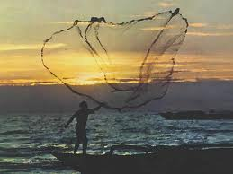

They do not jostle each other; each marches straight ahead. They plunge through defenses without breaking ranks. Joel 2:8
New International Version (©1984)

The Body of Christ is arising as an army
Here at the beginning of 2013, much ground is being taken for Christ, as unity, truth and love between His members is increasing and a growing awareness that denominational barriers are fading into insignificance in the light of the love we have for our brothers and sisters in God’s family . As we are becoming more effective we are also seeing increasing battles in our circles of fellowship, as issues are coming to a head to be resolved . On the 12th December 2012 at the end of a day of listening to the Lord, a strategy was revealed to build a prayer wall that will endeavour to help to bring protection on every side for individuals and their families in this battle.

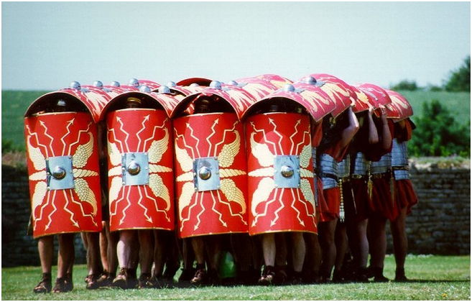
Roman shield tactics conquered the known world at the time.

Protection on every side

In Roman history when a fortress was being taken, the soldiers attacking below were in great danger from the arrows raining down from above. The soldiers would raise their shields above their heads, linking them with the others. Moving forward close enough together, this strategy proved to be an effective, massive ‘metal umbrella’ protecting the whole attacking force. The Prayer wall is designed to work in a spiritual sense similarly to help conquer the forces of darkness and could serve to protect each 'soldier' from the attacks of satan and his cohorts, helping to keep the ‘soldiers’ strong as they pull down the fortress and strongholds of the enemy, bringing victory and the Kingdom of heaven into their families and communities as more of the enemy’s ground is taken.
The prayer wall could be of great benefit to those who are willing to pray for themselves and four others everyday for blessings, protection and for victorious breakthrough. They in turn will also be covered in prayer on every side. This constant coverage could mean more freedom and greater victory for the individual where breakthrough has previously proved difficult or even impossible, thus consequently strengthening the whole. As this wall of prayer grows naturally between the ‘soldiers’ of God’s army who love, trust and are concerned for one another, it has the potential to become an infrastructure running through and undergirding all types of denominations, cutting across different nationalities, gender and class within the Body of Christ.

The concept of five

When the idea came, it was just a vague picture of five praying for each other yet linking up and growing to become a network. It became an exciting challenge to see how it could work out mathematically. Endeavouring to be led by the Spirit a pattern started to take shape.
This following illustration shows how a strategic prayer network could prove to be simple, yet effective. You can click into the diagram if your are reading this online. It will change to an Excel worksheet and you can hover your mouse over the named boxes.
(Please excuse the fictitious names chosen in a lighter moment and to avoid boredom to the author!!!)
In this model Prayer Wall below (illustration 1a) John Smith has selected four people (surrounding him diagonally) who he would like to commit to pray for every day, and for them to pray for him.

Illustration (1a) A Model of the Beginnings of a Prayer Wall

Fred Bloggs Q2, one of John’s choices, says “Yes” to John’s request, changes his box to red and links with P14 John Smith. John then requests three others to make up his four; Sally Forth, Billy Bunter and Phil Philpot. John and Fred are the only two, at this stage in the prayer wall, who are praying for each other. They will be fully covered as soon as those requested confirm and change their yellow box to red. However, for example, if Sally Forth agrees, she then needs to choose two others for boxes N13 and N14 to come on board so she can have full prayer coverage. You can see how this could soon grow. The secret is in praying and asking for wisdom in choosing the right people who can be trusted to care enough to be committed to pray. If you choose to be part of the network, be wise in your selections.

The way the ‘wall works’ will mean that individuals will sometimes have a stranger linked to them. Bear in mind that although they are a unknown to yoy they are family and have been prayerfully chosen. This necessity to be linked to the unfamiliar should be viewed as a positive as it will help the body of Christ link and unite, thus expanding circles of fellowship to grow. This will consequently bring more power and strength individually and corporately as different gifts are also being introduced.

Each member should find out in loving concern about the people they are praying for and also to keep contact with them to get updates for their particular prayer needs and circumstances.

Help with the instructions on how to add your name to the Real Prayer Wall is at the back of this booklet. The link to the AAC Prayer Wall can be found on www.houseofbread.net.

Listening closely to God
There is always the possibility of inviting the wrong person to come on your team of prayer warriors, unless the Lord is involved with your decision. The person might be a very good Christian, but could turn out to be more of an enemy than a friend if their agenda, vision and motive is at variance to that of the Prayer Wall. This Prayer wall is not based on any particular personality or ministry, but made up of ordinary Christians doing extraordinary things for God, for the good of all concerned. Jesus Christ is the Chief Corner Stone and He is the foundation that we build upon.
It is important to listen closely to the Holy Spirit when making selections. You are looking for ‘soldiers’ who you know have a heart for God and a motive to bring the Kingdom of God on the earth and not build their own empire. They may be struggling in the battle, but that shouldn’t disqualify them. The main thing is to ask the Holy Spirit to show you who to ask. He always gives wisdom to those who ask. James 1:5

Praying for the wounded and newborn

You will notice on the Prayer wall there are white gaps surrounding the ‘bricks’. On the actual Prayer wall these have been made blue. These slots can be used for people you know are too weak to join the ‘soldiers’. They will not be praying for anyone but will have the advantage of being bathed in prayer by the surrounding soldiers. These gaps can also be used for new born baby Christians who need support at the beginning of their journey until they are strong.

The vision

Jesus has already won every war and defeated every foe. He left the Body of Christ with the Holy Spirit to assist with the task of claiming back that which He has already won at Calvary.

Tommy Hicks, an evangelist, who was used by the Lord in the great Argentine Revival had a vision in 1961 of a strong army of Christians arising like a giant to take the land for Christ. You can download a copy of this vision on www.houseofbread.net
Here is an excerpt:

As the lightning flashed over the face of the earth, my eyes went downward – and I was facing the north. Suddenly I beheld what looked like a great giant. As I stared and looked at it, I was almost bewildered by the sight. The giant was gigantic. His feet seemed to reach to the north pole and his head to the south pole. His arms were stretched from sea to sea. I could not even begin to understand whether this was a mountain or whether this was a giant. As I watched, I suddenly beheld that it was a great giant. I could see he was struggling for life, to even live. His body was covered with debris from head to foot; and at times this great giant would move his body and act as though he would rise up. When he did, thousands of little creatures seemed to run away. Hideous looking creatures would run away from this giant and when he would become calm, they would come back.

All of a sudden this great giant lifted one hand toward the heavens, and then he lifted his other hand. When he did, these creatures by the thousands seemed to flee away from this giant and go out into the night.

Slowly this great giant began to rise – and as he did, his head and hands went into the clouds. As he arose to his feet he seemed to have cleansed himself from the debris and filth that was upon him, and he began to raise his hands into the heavens as though praising the Lord. As he raised his hands, they went even unto the clouds.

The main interpretation for this vision was of the members of the Body of Christ coming together in unity, arising from the things that held them down, becoming strong and glorifying God. Many Christians have been struggling and entangled in difficult situations unable to follow their dreams because of demons that are assigned to each person to try to hold them down and back. For breakthroughs in these precious lives they need the support, love and prayer to help them find victory and take their positions. The purpose of the Prayer wall is to endeavour to assist what God is already doing with His people and to link them together in a caring environment of prayer and love. Instead of the body of Christ working on the defensive to survive, the following prayer points will help individuals to be on the offensive against the kingdom of darkness and gain ground for the Kingdom in their lives, families and communities.

Effective Prayer points

1. Bind the enemy and all his evil workers from bringing division, offence or misunderstanding into your group or the prayer wall. Bring the plans and purposes of the enemy and his evil workers to nothing for yourself and your group's individuals in Jesus's mighty name.
In agreement with the whole prayer network I forbid the enemy or his evil workers to cause any division, offense or misunderstanding between any of the members of my group or any in this prayer wall, I bring the enemy's and his evil workers plans and purposes to nothing, for myself and family and my group's individuals (name them) In Jesus's mighty name.

2. Loose unity, harmony and clarity into your group and the Prayer Wall. Agree in the Name of Jesus that every plan of God will come about for yourself and the group's individuals
In Jesus's Name, I ask the Holy Spirit to bring love, unity, peace and clarity within the network. I agree with the whole prayer network that God's will shall be done for myself and (name your group's individuals) and that we will fulfil our destiny.

3. Pray for yourself and the group to know God's love and so grow to maturity. Ephesians 3.18
In the name of Jesus I ask for myself and (group's names) that we will know the height, depth, breadth and length of God's love, so we will all come into the fullness of God, in agreement with the whole prayer network.

4. Pray that your's and your group's family and belongings are kept safe and that you will all be restored in every area that the enemy has stolen from all of you.
Father, please keep my family and belongings safe and restore to me all that I have lost or had stolen. I ask this for (group's names) In Jesus's Name in agreement with the rest of the Prayer Network

How to add your name to the prayer wall
Go to www.houseofbread.net Click into the right hand top corner link...



This will open the Prayer wall page. All the instructions can be found when opening the page. However if you need further assistance, the following may help:

- Click into one of the white cells diagonally adjoining one of the red cells. If a friend has requested you join in their 'group', select a white cell next to them. You may find your friend has already chosen a cell for you, provisionally. (the blue cells are kept for people who are in need of prayer but are not included in the wall as prayer warriors.

- Add your name to the Prayer Wall, next to the Cell Name (eg. M14) and not deleting the Cell Name. This Cell Name will be your Unique Identifier.This Cell Name will be your Unique Identifier.

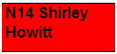

- Right click in your cell and click on INSERT NOTE. Bearing in mind that this page is only available to those who have the link, if you don't mind your mobile phone number being available to others on the prayer wall then add it as a note. You may want to just share your details of email, landline, mobile or face book etc with your prayer partners. There is also the option of inserting a comment as you right click on your cell. You and your group could use this facility to post prayer requests etc.

- To confirm your name stay in the cell and click into the small paint pot on the toolbar above and choose red to alter the background colour. (You can save a cell for a friend before they've confirmed by temporarily making it yellow). That's it!, once you've confirmed your name, you are part of the Prayer Wall. Remember to pray faithfully every day for your group and yourself


- There is very important information on the next excel spreadsheet that you need to read (Click Prayer format at the bottom left of this page).
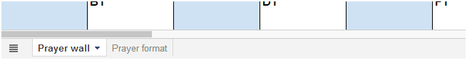
Some prayer points that may prove to be essential can be found on this page.

- To get your full prayer coverage prayerfully select other prayer warriors to add to your surrounding network of four. Give them your cell name and copy and paste the above URL into an email so they can access this site or tell them to go to www.houseofbread.net for link to this page. For your friends and yourself, all information about the Advancing Armies of Christ Prayer Wall, is at www.houseofbread.net If you need any help, please ring Shirley on 07951389403 or email shirleyhowitt@yahoo.co.uk

